ASSIGNMENT NO-9
Que 1) write a query that lists each other number followed by the name of the customer who made the order.
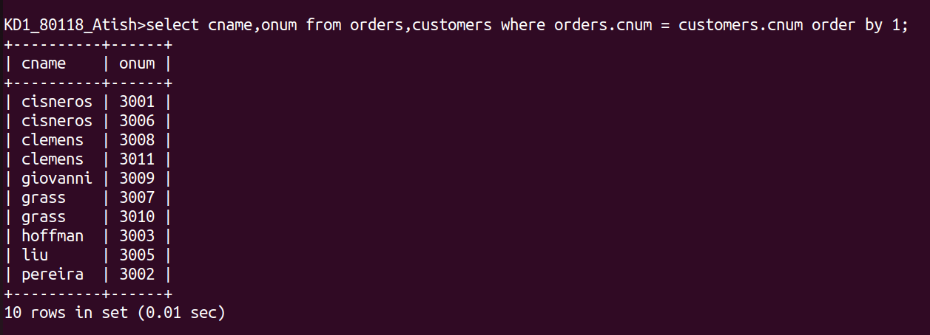

Que 2) write a qeuery that gives the names of both the salesperson and the customer for each other along with the order number
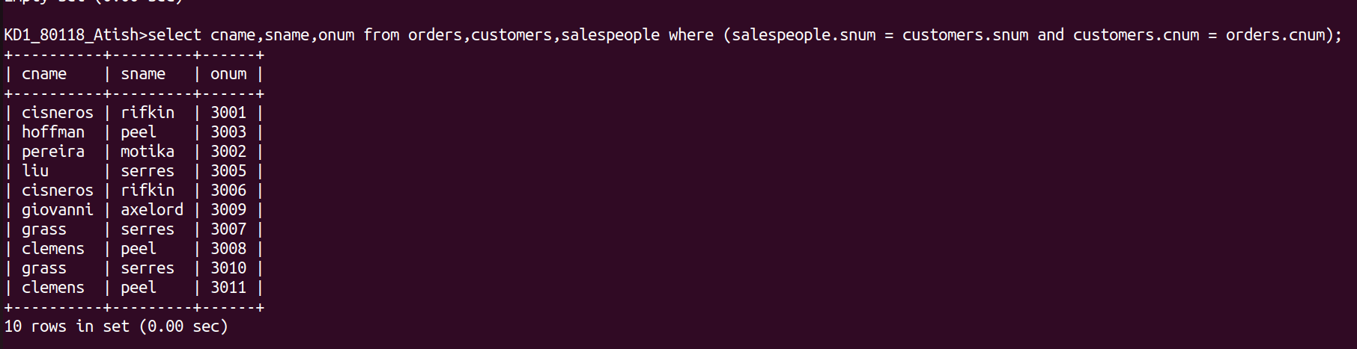
Que 3) write a query taht produces all customers serviced by salespeople with a commission above 12% .output the customers’s name ,the salesperson’s name,and the salesperson’s rate of commission
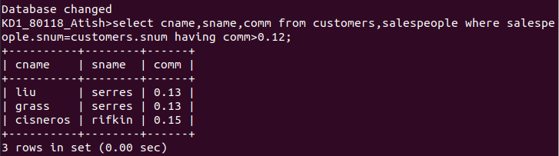

Que 4) write a query that calculates the amount of the salesperson’s commission on each order by a customer with a rating above 100
